Date and Time: TBD 6.30pm-8.00pm
Location: BCS, The Chartered Institute for IT, 25 Copthall Ave, London EC2R 7BP
Title: The AI-Powered Consultant: Mastering AI-Prompting as Your New Superpower
Speaker: Dr Alan Warr
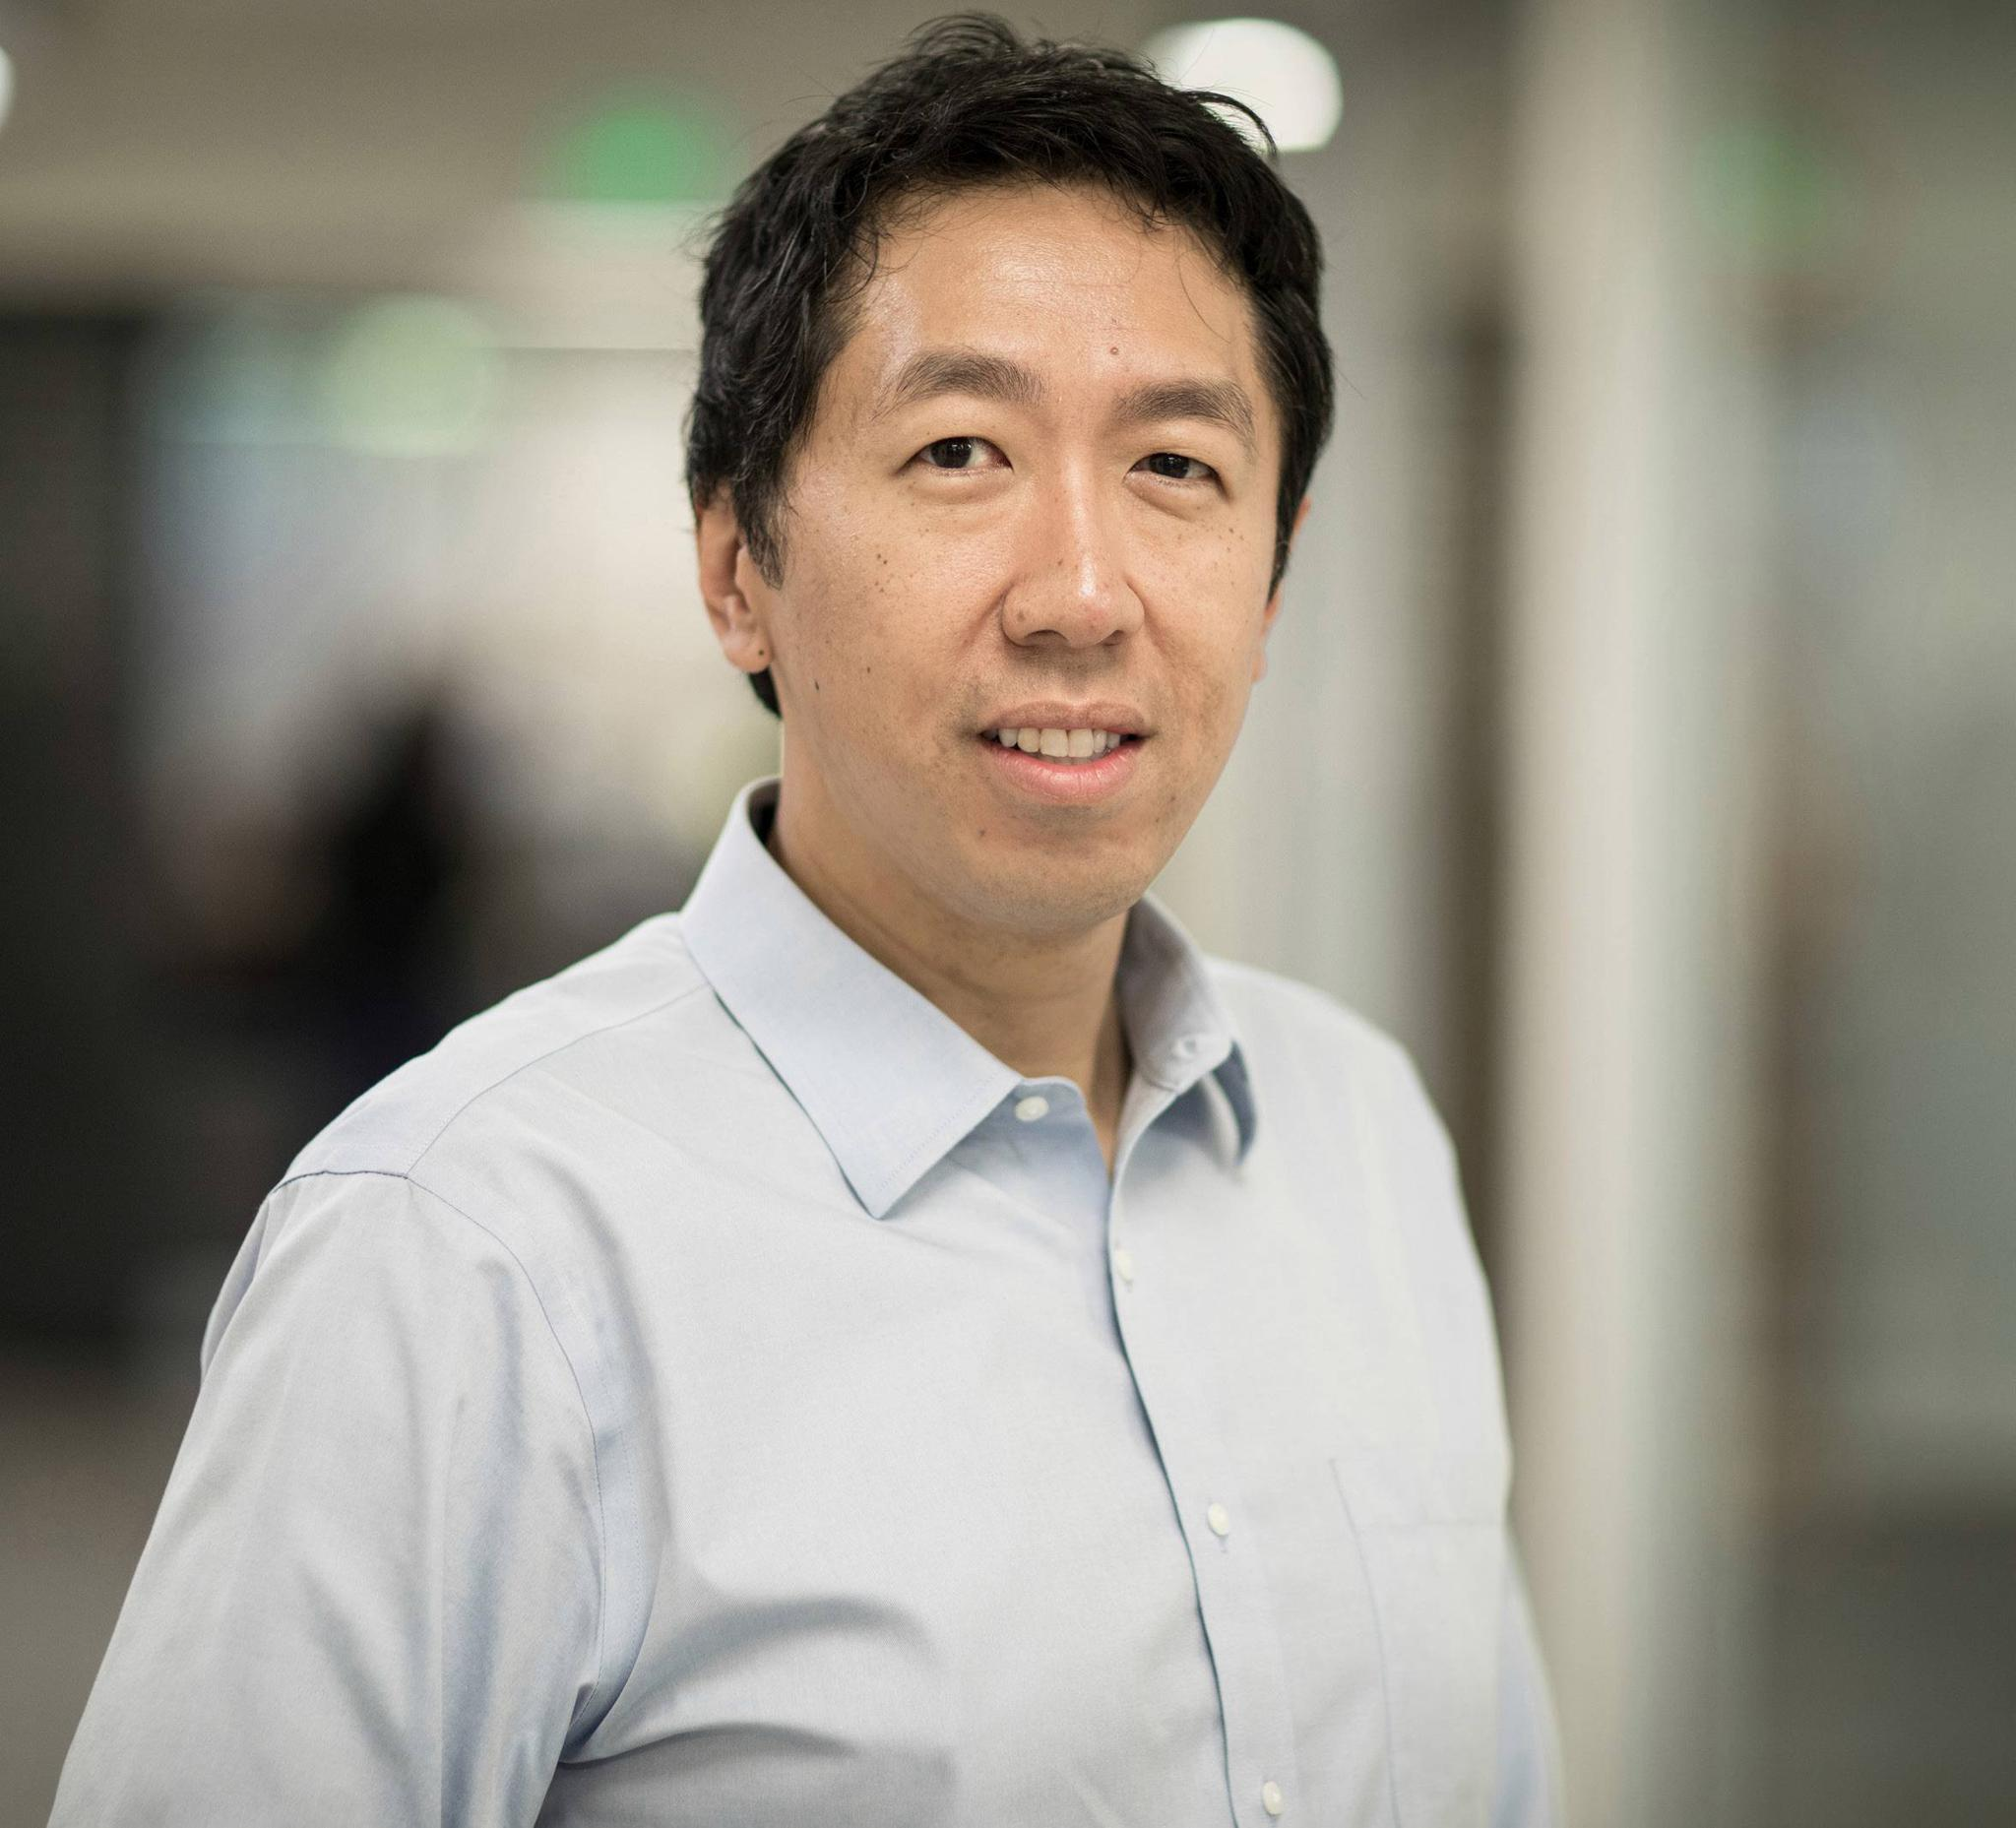
“AI is the new electricity. Just as electricity transformed almost everything 100 years ago, today I have a hard time thinking of an industry that I don’t think AI will transform in the next several years …….. As AI changes the nature of work, it will also change the nature of skills that people need to stay employed. Prompting AI will be one of the most important skills for professionals in the future.” — Andrew Ng, Stanford Professor in AI, and co-founder of Google Brain and Coursera
In November 2022, when OpenAI launched a free AI Chatbot called ChatGPT, the world woke up to the startling progress that this AI team and others had been making. Within days 1 million users signed up and within 6 months over 100 million people were using it. Its ability to respond to questions and instructions – called Prompting - stunned people. It was trained on the whole accessible Internet and other sources. It was extremely knowledgeable. Very senior people claimed it seemed to be sentient. Tech leaders (including OpenAI) called on governments for regulation and speculation that future GPTs posed an existential threat to mankind gained credibility in the media. Strategy houses and government policy units coalesced around the prediction that 40% of work in advanced economies would be automated or enhanced with this type of Generative AI. Governments are moving, tech giants are trying to mitigate risks but the pace of development and explosion of technology developments continues at pace.
This working session by Dr Alan Warr focuses on Prompting AI. The designers of the Foundation LLMs, that power these ChatBots, built in incredibly sophistication into how they respond. Recent research suggests that consultants and similar professionals are using them in their professional work. But in a mostly in a basic way, so far. There is a whole lot more to Prompting AI than asking a conversational question and getting back a stunning output. From designing advanced Prompts, through Agents to personal LLM applications, there is a rich domain of potential to be exploited. Through a series of demos, Alan will start with basic AI prompting and keep ratcheting up the sophistication with use cases relevant to consultancy and other similar business professionals. Finally pointing to the recent potential for professionals and teams to build LLM-powered apps exploiting their own internal knowledge & data. Something the big consultancies are actively working on now.
Agenda:
- Introduction to Generative AI, foundation LLMs, Chat GPTs and AI Prompting
- Basic Prompting – one-shot, role, agent, chain of thought, etc.
- Advanced Prompting –
- Embedded Prompting – Co-pilots
- Prompt-Enabled Applications – Retrieval Augmented Generation
- Next Horizons – Local LLM apps, LLM Fine Tuning, GPT Agents
- What does the future hold – GPT5 and beyond
- Q&A and participant contributions & demos
The workshop will restrict itself to the OpenAI and Midjourney LLMs. And coding to Colab/Python. This aims to keep the focus on Prompting. But recognizing that there are many other foundation LLMs, the resources provided will include how to apply the demos across the major rival technology stacks too.
The workshop is not designed for AI researchers and LLM application developers who will find it introductory. It is really aimed at consultancy and business professionals who are ready to start building their Prompting AI skills ahead of others into a SuperPower.
About the speaker:

Dr Alan Warr BA MSc MBA PhD MBCS CITP – Alan has been a management consultant focused on applying IT, Data and AI to real-world business problems for over four decades. He has master’s degrees in computer science and business management and a PhD in the strategic management of IT/Data/AI. He is a graduate of the JovianAI data science/AI bootcamp and the FacultyAI Data Engineering Fellowship. His consulting career has included senior consulting delivery roles at PA, BT, Capita & KPMG. For the last four years he has consulted from his own boutique consultancy. Throughout his consulting career he has delivered Data Science & Applied AI solutions within his consulting portfolio and for the last few years this has been his main focus. Recently he has narrowed his consulting assignments to Generative AI strategies, applications & products.

